**Exercise 1: Logging Error Messages and Warning Levels**

**Task:**

Write a Java application that demonstrates logging error messages and warning levels using SLF4J.

**Code:**

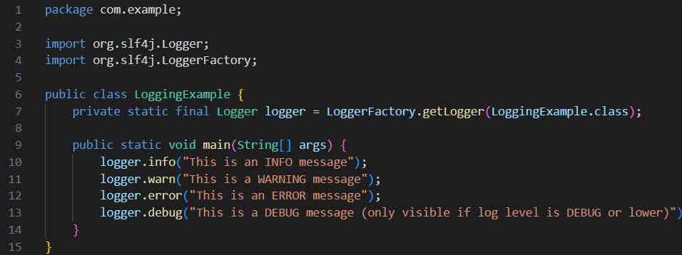

**Output:**

